Bottom of Form

**OhSINT**

Are you able to use open-source

intelligence to solve this challenge?

What information can you possibly get with just one photo?

Room link :: <https://tryhackme.com/room/ohsint>

Walkthrough Flow [As per my video];

* We first begin by downloading the task file, which has the following image;



Figure : WindowsXP.png

* To have a better look inside we will now run it through Exif-tool

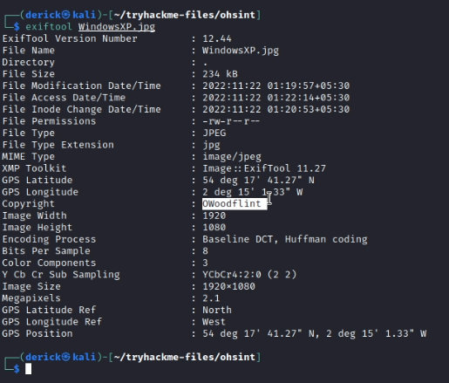

* We are able to find the name “OWoodFlint”, let now try and run a google search on it.

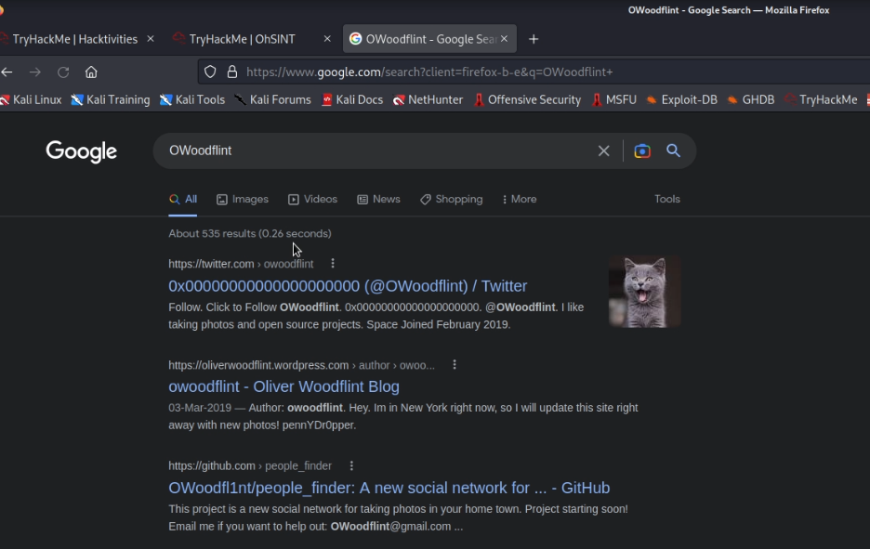

We can see sites for :: Twitter , WordPress and GitHub

* From the first site : Wordpress;

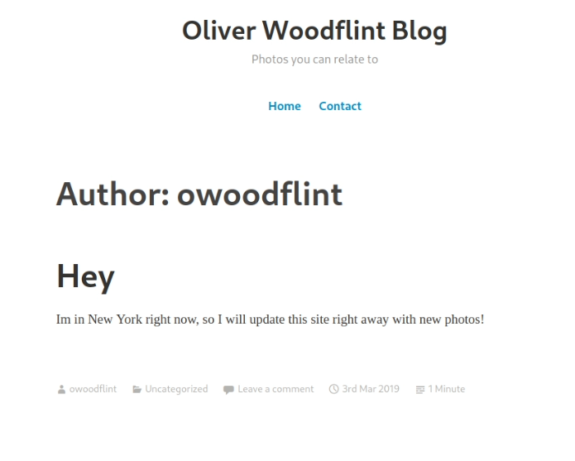

We are able to answer one of the questions. [That he is currently somewhere else]

* And then looking into the source code, I found an odd hidden text [Later to be found as the password]

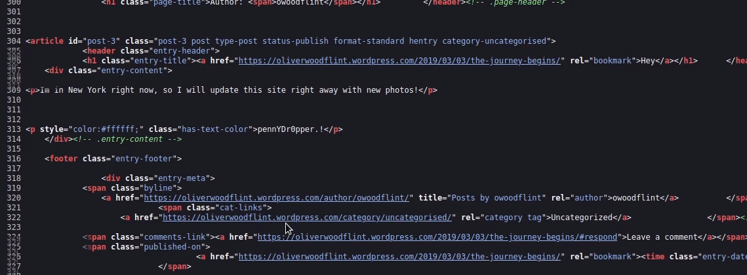

* Next going over to the twitter page;

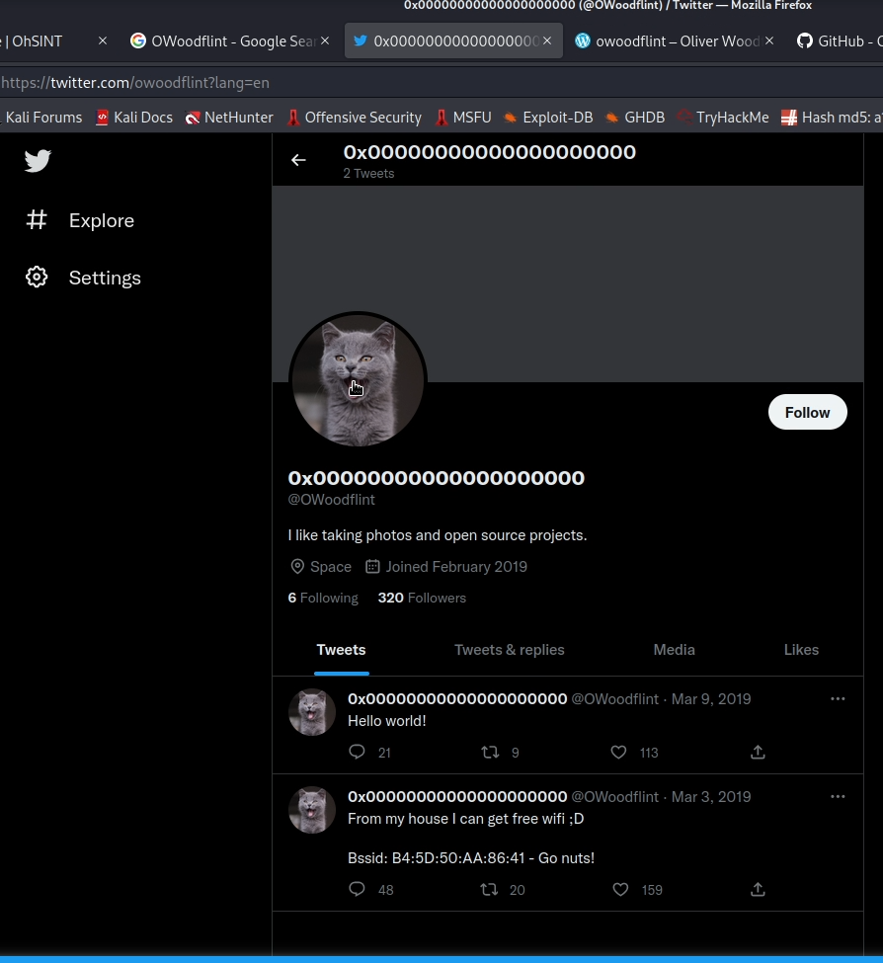

We are able to answer another question such as the user’s avatar and also come across the BSSID tweet. Taking this to wiggle.net and running a search.

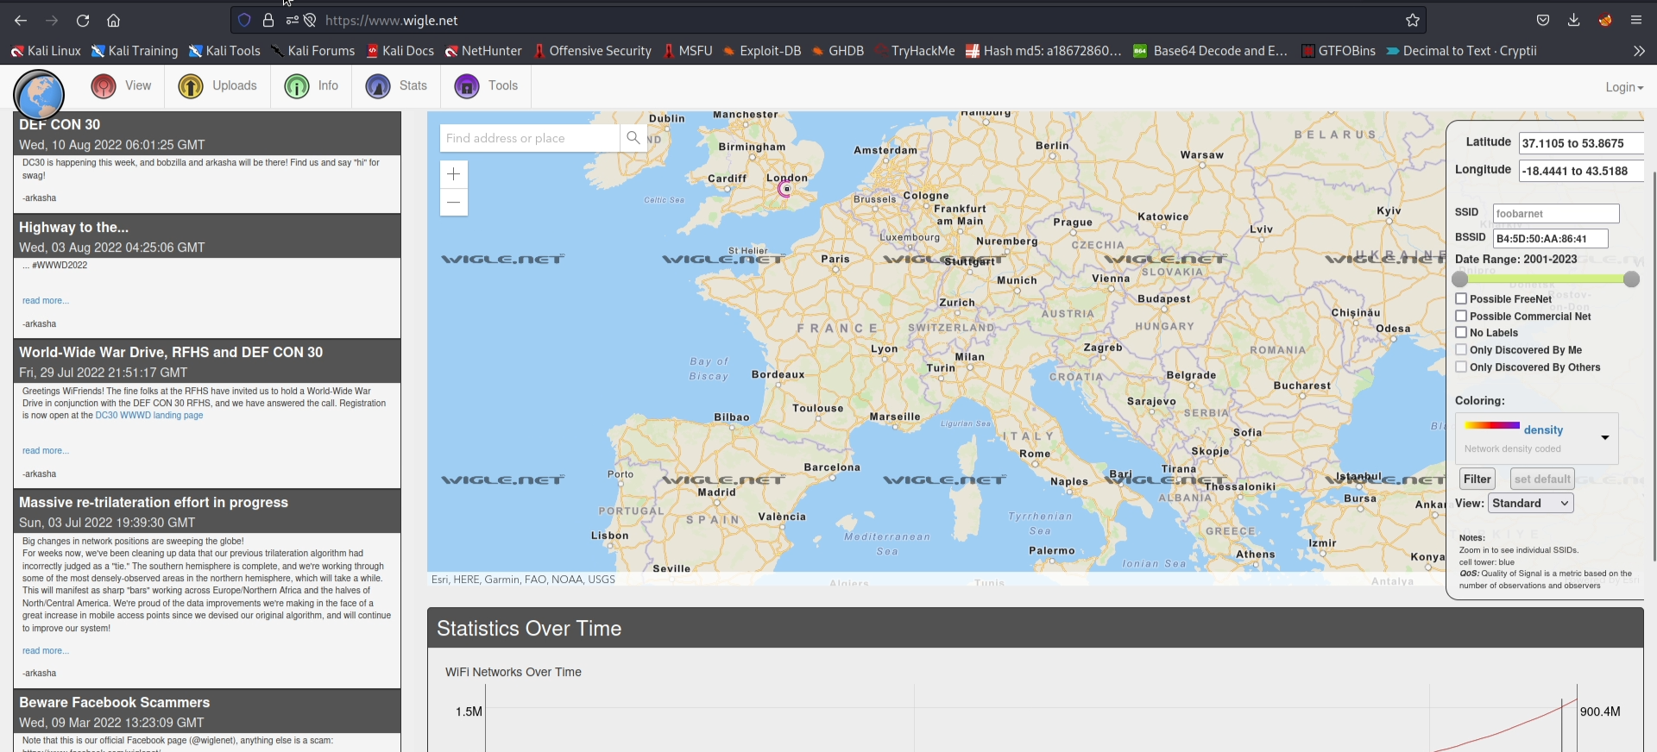

We can find the place where he lives. [another question answered there.]

* Hopping to the github profile

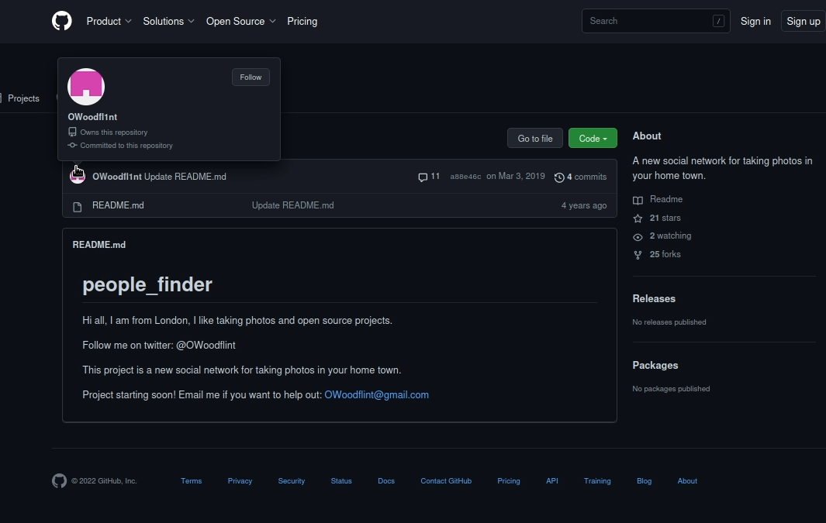

We can directly answer 2 more questions, regarding his email address and where it was found.

Lastly, the question for “ which WAP did his BSSID connect to “ was the question I found unsettling and was unable to find the answer.

I guess due to the change in the wiggle.net website dynamics or the nature of their UI, so I had to obtain my answer through a google search. [ It should be counted as OSINT, just not the proper way, I guess ]

So if anyone finds a way to get the answer through proper OSINT manner, drop a comment on the video or share your method through GitHub and let me know, so I can make the necessary changes.

Thanks for viewing this Walkthrough. !!